# Layer Up

## Game Summary

2d platformer, you have 2 minutes to complete the game.

Each time you complete a level, it resets to the beginning of the same level, but a layer of the game is removed.

Each layer is one closer to a star or princess or bowl of noodles and removing the last one will give you access to it and complete the game. “You got the noodles before they become cold”.

## Feelings

Want to invoke fast paced speed running feeling.

## Core Mechanics:

1. Player Movement – Running, Jumping
2. Completing Levels – By getting to a thing that restarts the level, but a layer is removed.
3. (Final Collectable) – To finish game.
4. Timer – To get to the end goal before timer runs out.

## Game Play

You start the game and there is a relatively easy platformer with an obvious goal (maybe like an egg timer).

You jump the obstacles to get to it and then you get warped to the beginning, but one layer is removed, and you need to do it again but this time platforms are removed and thus the game gets harder, and mistakes will cost your time more.

If unable to complete it will say “you were unable to save the noodles (or whatever final item is)”.

If you win it will save your time in the main menu as the time to beat.

## Music:

Sound Effects – Mainly the player built in ones.

Music – Some fast paced or speed running music to create a fast-paced flow feeling.

## Art Style:

This will be a simple platformer art as a full controller has been built in with it.

I am open to changing this, but it does fit the theme of cute easy platformer. Potentially thinking of changing the theme to more of an old arcade game 2d character.

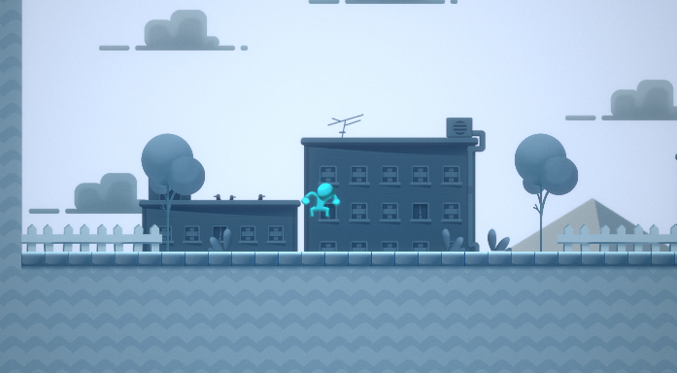

## Visualization

Imagine landing a certain timed jump so you can go one layer than you did last run.

On screen there is a timer the player and the level and the current layer number.

